Creating the Find Method
Developing the Middle Layer

Creating the Methods 1
Before you Begin 1
A Quick Overview 1
Create a Fresh Branch 2
Creating the testing 2
Hard Coded Data Layer 5
Merge the Branch to the Master 26

Creating the Methods

Before you Begin
Make sure that you have completed the work for last week and that you have watched the eLectures for this week before starting this work.

Having created the testing for the properties of clsAddress we need to think about how to approach building the methods for the class.
There are two methods in the class Find and Valid.
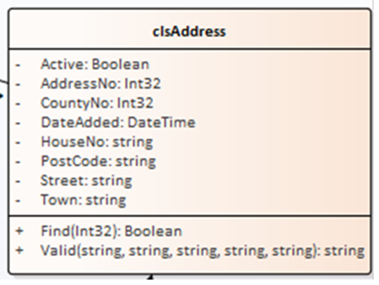

Let’s have a go at Find first.

A Quick Overview
We need to think a little about how this method is going to work.
Let’s assume that the table in the database contains the following data…
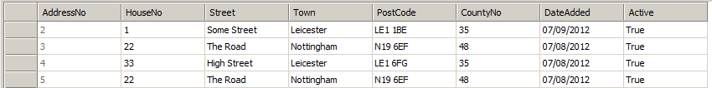
How the method works is that we will always send it the value of a record’s primary key we want to find e.g. 2.
If record 2 is found the method will return a value of true, otherwise false.
As well as returning true or false the method also needs to return the data for all fields of the record being searched for.
For example
clsAddress AnAddress = new clsAddress();
AnAddress.Find(2);
string Street = AnAddress.Street;

Would set the value of the variable Street to “Some Street”.
What we will eventually do is set up some test data in the table that will be used to check that the method is returning the data we think it should be.

Create a Fresh Branch
Remember, this is a new Git Hub working day. You need to make sure you have completed the previous work to perfection and closed any existing branches.
As per usual you will need to create a blank folder and clone a fresh copy of the master to the folder.
Also make sure you create a new branch to complete this work.

Creating the testing
The simple things first, we need to create a test to ensure the existence of the method. Ad this new test to our class under the other tests for the properties. (In my case tstAddress.)
Like so…
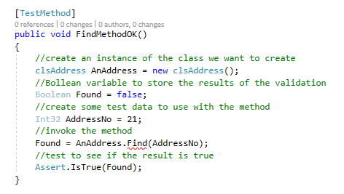
Find should be underlined in red as shown above.
Run the test – watch it fail and then fix it by creating the method.
Remember, hold the mouse over the failing test…
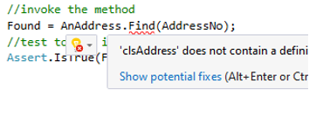
Next click, show potential fixes…
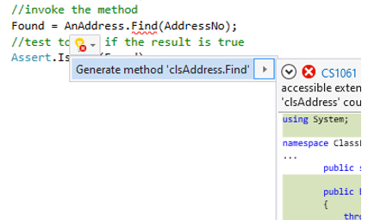
Generate the method.
Run the tests again.
It should still fail due to the code in the class not being right.
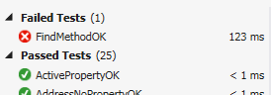
One of the features of TDD is that we can put in a quick fix to problems simply to make the test pass.
Look in the class clsAddress at the auto generated code…
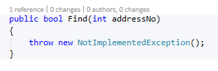
By design, the new method is set up to throw an exception.
Change the auto generated code such that the test passes. This makes the test pass, but it clearly isn’t the final code.
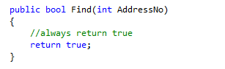
The test should now pass.
Modifying the Find method on clsAddress to always return true forces the test to pass but doesn’t exactly fix the problem in the long term.

Hard Coded Data Layer
Before we add any data to the database, we will start by hard coding the data layer to simulate the data being accessed.
We need to create a series of tests that search for the record and ensure that the correct data is being returned.
The first test in tstAddress is as follows…
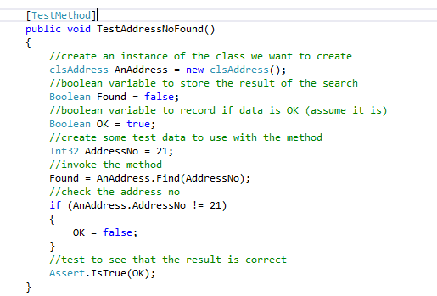
This test finds record number 21 and checks to see if the AddressNo property is also set to 21.
As usual the test should fail…
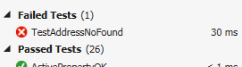
Let’s fix the problem to see if we can resolve the failed test.
To make this work we need to make some modifications to the class clsAddress.
Firstly, we need to create a private data member for the public property…
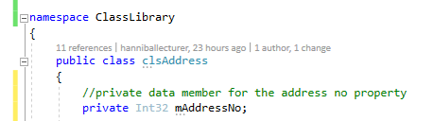
Next, we need to change the structure of the public property from this…
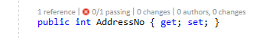
To this…
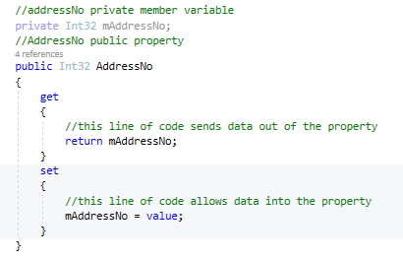
Creating a private member variable and a getter and setter …
Next, we need to modify the Find method to set the private data member so that it can be returned via the public property…
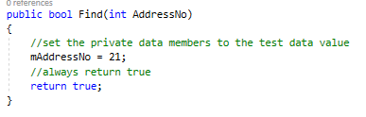
This code is basically rubbish but it allows us to write our testing.
- It can only ever search for record number 21
- It is not drawing any data from the database
Let’s try the test again…
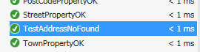
The good news is that it passes. The bad news is that the fix is still a bit rubbish, but we don’t care about that!
You will now need to create similar tests for each attribute in your class.
Adding private data members and modifying the public properties as you do.
For example, here is the next test but this time for DateAdded…
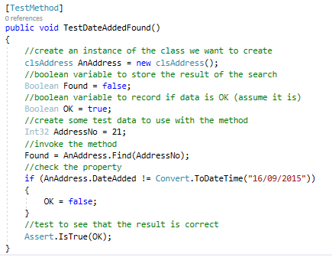
This test looks for record 21 and tests to see that it has a date of “16/09/2015”
You will need to modify the find function to provide the simulated data…
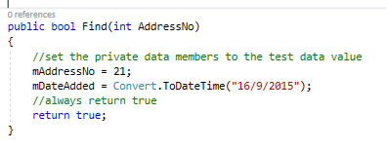
You will also need to modify the existing property to include a private member variable and a getter and setter…
For example…
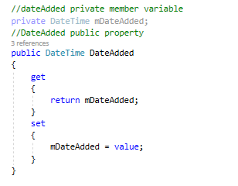
Data member
Public property
You will need to do this for each attribute in your class. Here is the full version of my testing code including code from last week at the top…

using System;
using Microsoft.VisualStudio.TestTools.UnitTesting;
using Class_Library;

namespace Test_Framework
{
[TestClass]
public class tstAddress
{
[TestMethod]
public void InstanceOK()
{
//create an instance of the class we want to create
clsAddress AnAddress = new clsAddress();
//test to see that it exists
Assert.IsNotNull(AnAddress);
}

[TestMethod]
public void ActivePropertyOK()
{
//create an instance of the class we want to create
clsAddress AnAddress = new clsAddress();
//create some test data to assign to the property
Boolean TestData = true;
//assign the data to the property
AnAddress.Active = TestData;
//test to see that the two values are the same
Assert.AreEqual(AnAddress.Active, TestData);
}

[TestMethod]
public void DateAddedPropertyOK()
{
//create an instance of the class we want to create
clsAddress AnAddress = new clsAddress();
//create some test data to assign to the property
DateTime TestData = DateTime.Now.Date;
//assign the data to the property
AnAddress.DateAdded = TestData;
//test to see that the two values are the same
Assert.AreEqual(AnAddress.DateAdded, TestData);
}

[TestMethod]
public void AddressNoPropertyOK()
{
//create an instance of the class we want to create
clsAddress AnAddress = new clsAddress();
//create some test data to assign to the property
Int32 TestData = 1;
//assign the data to the property
AnAddress.AddressNo = TestData;
//test to see that the two values are the same
Assert.AreEqual(AnAddress.AddressNo, TestData);
}

[TestMethod]
public void CountyNoPropertyOK()
{
//create an instance of the class we want to create
clsAddress AnAddress = new clsAddress();
//create some test data to assign to the property
Int32 TestData = 1;
//assign the data to the property
AnAddress.CountyNo = TestData;
//test to see that the two values are the same
Assert.AreEqual(AnAddress.CountyNo, TestData);
}

[TestMethod]
public void HouseNoPropertyOK()
{
//create an instance of the class we want to create
clsAddress AnAddress = new clsAddress();
//create some test data to assign to the property
string TestData = "21b";
//assign the data to the property
AnAddress.HouseNo = TestData;
//test to see that the two values are the same
Assert.AreEqual(AnAddress.HouseNo, TestData);
}

[TestMethod]
public void PostCodePropertyOK()
{
//create an instance of the class we want to create
clsAddress AnAddress = new clsAddress();
//create some test data to assign to the property
string TestData = "LE1 4AB";
//assign the data to the property
AnAddress.PostCode = TestData;
//test to see that the two values are the same
Assert.AreEqual(AnAddress.PostCode, TestData);
}

[TestMethod]
public void StreetPropertyOK()
{
//create an instance of the class we want to create
clsAddress AnAddress = new clsAddress();
//create some test data to assign to the property
string TestData = "Some Street";
//assign the data to the property
AnAddress.Street = TestData;
//test to see that the two values are the same
Assert.AreEqual(AnAddress.Street, TestData);
}

[TestMethod]
public void TownPropertyOK()
{
//create an instance of the class we want to create
clsAddress AnAddress = new clsAddress();
//create some test data to assign to the property
string TestData = "Leicester";
//assign the data to the property
AnAddress.Town = TestData;
//test to see that the two values are the same
Assert.AreEqual(AnAddress.Town, TestData);
}
NEW CODE FROM HERE
[TestMethod]
public void FindMethodOK()
{
//create an instance of the class we want to create
clsAddress AnAddress = new clsAddress();
//boolean variable to store the result of the validation
Boolean Found = false;
//create some test data to use with the method
Int32 AddressNo = 1;
//invoke the method
Found = AnAddress.Find(AddressNo);
//test to see that the result is correct
Assert.IsTrue(Found);
}

[TestMethod]
public void TestAddressNoFound()
{
//create an instance of the class we want to create
clsAddress AnAddress = new clsAddress();
//boolean variable to store the result of the search
Boolean Found = false;
//boolean variable to record if data is OK (assume it is)
Boolean OK = true;
//create some test data to use with the method
Int32 AddressNo = 21;
//invoke the method
Found = AnAddress.Find(AddressNo);
//check the address no
if (AnAddress.AddressNo != 21)
{
OK = false;
}
//test to see that the result is correct
Assert.IsTrue(OK);
}

[TestMethod]
public void TestStreetFound()
{
//create an instance of the class we want to create
clsAddress AnAddress = new clsAddress();
//boolean variable to store the result of the search
Boolean Found = false;
//boolean variable to record if data is OK (assume it is)
Boolean OK = true;
//create some test data to use with the method
Int32 AddressNo = 21;
//invoke the method
Found = AnAddress.Find(AddressNo);
//check the property
if (AnAddress.Street != "Test Street")
{
OK = false;
}
//test to see that the result is correct
Assert.IsTrue(OK);
}

[TestMethod]
public void TestTownFound()
{
//create an instance of the class we want to create
clsAddress AnAddress = new clsAddress();
//boolean variable to store the result of the search
Boolean Found = false;
//boolean variable to record if data is OK (assume it is)
Boolean OK = true;
//create some test data to use with the method
Int32 AddressNo = 21;
//invoke the method
Found = AnAddress.Find(AddressNo);
//check the property
if (AnAddress.Town != "Test Town")
{
OK = false;
}
//test to see that the result is correct
Assert.IsTrue(OK);
}

[TestMethod]
public void TestPostCodeFound()
{
//create an instance of the class we want to create
clsAddress AnAddress = new clsAddress();
//boolean variable to store the result of the search
Boolean Found = false;
//boolean variable to record if data is OK (assume it is)
Boolean OK = true;
//create some test data to use with the method
Int32 AddressNo = 21;
//invoke the method
Found = AnAddress.Find(AddressNo);
//check the property
if (AnAddress.PostCode != "XXX XXX")
{
OK = false;
}
//test to see that the result is correct
Assert.IsTrue(OK);
}

[TestMethod]
public void TestCountyNoFound()
{
//create an instance of the class we want to create
clsAddress AnAddress = new clsAddress();
//boolean variable to store the result of the search
Boolean Found = false;
//boolean variable to record if data is OK (assume it is)
Boolean OK = true;
//create some test data to use with the method
Int32 AddressNo = 21;
//invoke the method
Found = AnAddress.Find(AddressNo);
//check the property
if (AnAddress.CountyNo != 1)
{
OK = false;
}
//test to see that the result is correct
Assert.IsTrue(OK);
}

[TestMethod]
public void TestDateAddedFound()
{
//create an instance of the class we want to create
clsAddress AnAddress = new clsAddress();
//boolean variable to store the result of the search
Boolean Found = false;
//boolean variable to record if data is OK (assume it is)
Boolean OK = true;
//create some test data to use with the method
Int32 AddressNo = 21;
//invoke the method
Found = AnAddress.Find(AddressNo);
//check the property
if (AnAddress.DateAdded !=Convert.ToDateTime("16/09/2015"))
{
OK = false;
}
//test to see that the result is correct
Assert.IsTrue(OK);
}

[TestMethod]
public void TestActiveFound()
{
//create an instance of the class we want to create
clsAddress AnAddress = new clsAddress();
//boolean variable to store the result of the search
Boolean Found = false;
//boolean variable to record if data is OK (assume it is)
Boolean OK = true;
//create some test data to use with the method
Int32 AddressNo = 21;
//invoke the method
Found = AnAddress.Find(AddressNo);
//check the property
if (AnAddress.Active != true)
{
OK = false;
}
//test to see that the result is correct
Assert.IsTrue(OK);
}
}
}

Here is the finished code as it stands for the class clsAddress

using System;
using System.Collections.Generic;
using System.Linq;
using System.Text;

namespace Class_Library
{
public class clsAddress
{

//private data member for active
private Boolean mActive;
//public property for active
public bool Active
{
get
{
//return the private data
return mActive;
}
set
{
//set the private data
mActive = value;
}
}

//private date added data member
private DateTime mDateAdded;
//public property for date added
public DateTime DateAdded
{
get
{
//return the private data
return mDateAdded;
}
set
{
//set the private data
mDateAdded = value;
}
}

//private data member for the AddressNo property
private Int32 mAddressNo;
//public property for the address number
public int AddressNo
{
get
{
//return the private data
return mAddressNo;
}
set
{
//set the value of the private data member
mAddressNo = value;
}
}

//private data member for county no
private Int32 mCountyNo;
//public property for county no
public int CountyNo
{
get
{
//return the private data
return mCountyNo;
}
set
{
//set the private data
mCountyNo = value;
}
}

//private data member for HouseNo
private string mHouseNo;
//public property for house no
public string HouseNo
{
get
{
//return private data
return mHouseNo;
}
set
{
//set the private data
mHouseNo = value;
}
}

//private data member for post code
private string mPostCode;
//public property for post code
public string PostCode
{
get
{
//return the private data
return mPostCode;
}
set
{
//set the private data
mPostCode = value;
}
}

//private data member for street
private string mStreet;
//public data member for street
public string Street
{
get
{
//return the private data
return mStreet;
}
set
{
//set the private data
mStreet = value;
}
}

//private data member for town
private string mTown;
//public data member for Town
public string Town
{
get
{
//return the private data
return mTown;
}
set
{
//set the private data
mTown = value;
}
}

public bool Find(int AddressNo)
{
//set the private data members to the test data value
mAddressNo = 21;
mHouseNo = "123";
mStreet = "Test Street";
mTown = "Test Town";
mPostCode = "XXX XXX";
mCountyNo = 1;
mDateAdded = Convert.ToDateTime("16/9/2015");
mActive = true;
//always return true
return true;
}
}
}

Merge the Branch to the Master
That’s another Git Hub day completed – remember to merge your perfect code to the master and delete your unwanted branch.

